Table of Contents

1. Title: 2

2. Abstract: 3

3. Objective: 3

4. Results: 3

4.1. Simulation Environment: 3

4.2. Simulation Results: 8

4.3 Discussion: 11

5. Conclusion: 11

6. Reference(s): 11

**AMERICAN INTERNATIONAL UNIVERSITY–BANGLADESH (AIUB)**

**FACULTY OF ENGINEERING**

**MICROPROCESSOR AND EMBEDDED SYSTEMS**

**Spring 2021-2022**

**Section: A**

**Group: 02**

**Lab Report No: 06**

## Title:

**Controlling a motor through the application of PWM.**

**Submitted By:**

|  |  |
| --- | --- |
| **Group Member’s Name** | **ID** |
| Hasan, Mahmud | 17-33881-1 |
| Islam, Md. Ariful | 18-36842-1 |
| Alam, Ifta khirul | 18-36817-1 |
| Mulk, MD. Abdullah Al Malikal | 18-37803-2 |
| Rahman, Md Ashikur | 18-38519-2 |
| Islam, Sheikh Md. Samiul | 18-39261-3 |
| Muhaiminul Islam | 18-38920-3 |
| Ema, Fahamida Tanjiya | 18-38961-3 |

## Abstract:

From this experiment, our main goal is to build motor controller system. After building this we can control the speed of the motor. We can also move the motor towards the forward as well as to the backward direction. After performing this in Proteus, it will become a motor controlling system.

## Objective:

Our main objective from this experiment is to familiarize with Microcontroller based motor speed control. We need microcontroller because if we give any input using keyboard, microcontroller is required. Here we will use Proteus software to perform this experiment. Through this approach we will know how to perform the motor control system. We will also gather knowledge how to connect the LCD1 (Grove 218*64 OLED display Module), DC Motor, Arduino Button Breakout Board, POT-HG, the ground and the default input terminal together and make a motor controlling system. We will do this experiment using flowchart.

## 4. Results:

### 4.1. Simulation Environment:

Here we have click to New Project.

We have to click next again.

After that we have to select Create a schematic from the selected template and click next.

Then select Do not create a PCB layout and click next.

From the three option we have select the Create Flowchart Project and Family will be ARDUINO, Controller will be Arduino Uno, Compiler will be Visual Designer for Arduino AVR and click next.

Then we have to click Finish.

After that window will appear. It is for the simulation.

And this window is for the flowchart.

### 4.2. Simulation Results:

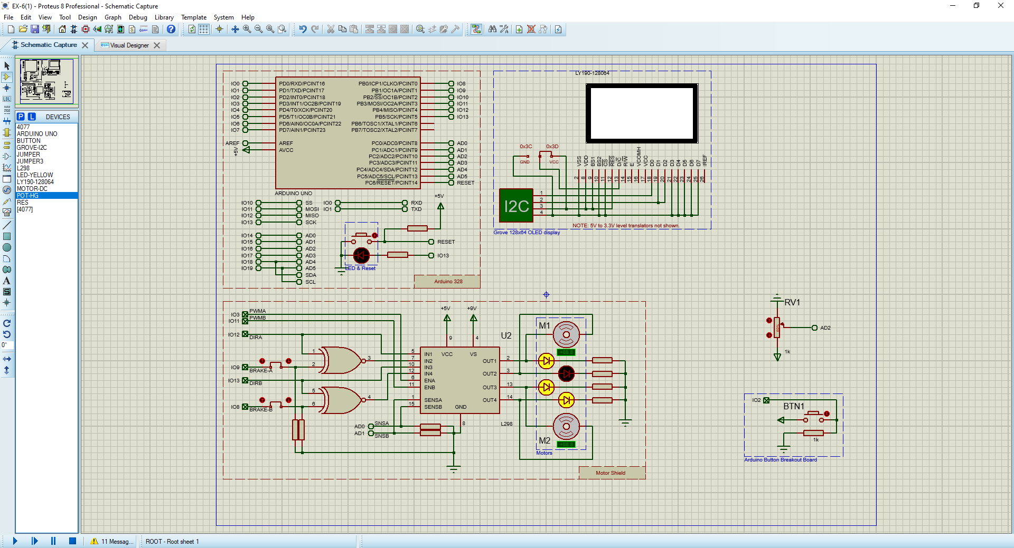

Figure 1: Motor Control System Circuit Design

This above picture shows the motor control system.

Figure 5: Red light is On

Figure 4: Red light is, yellow and green lights are off

Figure 3: Yellow light is on, red and green lights are off

Figure 2: Flowchart for the motor controlling system

The above picture is the flowchart for controlling the motor.

Figure 8: Source code for the simulation

Figure 7: Red and yellow lights are on

Figure 3: Speed controlling through the button breakout board

We can control the speed of the motor. We can also move the in backward and forward direction.

### 4.3 Discussion:

We have used grove 128*64 OLED display for displaying the speed of the motor. As we can see from the pictures above, we can control the speed of the motor willingly, as well as move the motor towards the backward and forward direction.

## Conclusion:

In this experiment we worked with motor control system. We have used Proteus 8.12 application as tools. We designed the circuit with the help of Proteus software and after designing we were able to implement it. We have learned many things from this experiment such as what Arduino is and how it works. How to make flowchart in Arduino, designing a circuit that will be helpful for the future.

## Reference(s):

1. https://www.arduino.cc/.
2. https://howtomechatronics.com/tutorials/arduino/arduino-dc-motor-control-tutorial-l298npwm-h-bridge/